Chapter 2.7
SPECIAL PLANNED DISTRICTS
***
The Bend Central District (BCD) code proposal is the final product of a 2012/13 TGM Grant developed through an 18-month public process that included interested citizens, property and business owners and staff. In October 2014 the City Council received a presentation on the project. The Bend Central District is one of the Opportunity Areas identified through the UGB process.
Article XIV. Bend Central District
2.7.3200 Bend Central District (BCD)
2.7.3210 Applicability
2.7.3220 Land Uses
2.7.3230 Development Standards
2.7.3240 Design Standards
2.7.3250 Parking Standards
2.7.3260 Street Standards
2.7.3270 Low Impact Stormwater Management
2.7.3280 Landscaping

***

2.7.3200 Bend Central District (BCD)
The Bend Central District is intended to implement the goals and objectives for the creative redevelopment of the central Third Street Corridor and surrounding areas west to the Parkway and east to and including 4th Street as indicated below:
- Provide for a wide range of mixed residential, commercial and office uses throughout the area and, depending on the parcel and its surroundings, vertical mixed use (i.e., a mix of uses within the same building), with an emphasis on retail and entertainment uses at the street level.
- Provide a variety of residential development types and greater density of development, with a transition area adjacent to the existing residential neighborhood east of 4th Street.
- Provide for development that is supportive of transit by encouraging a pedestrian-friendly environment.
- Provide development and design standards that support the goals of the Plan
- Limit development of low-intensity uses while allowing continuation of existing industrial and manufacturing uses.
- Provide reduced parking standards and encourage alternative parking arrangements.
The Bend Central District has distinctly different characteristics within the Bend Central District boundary. Subdistricts that recognize and support these characteristics are established as follows:
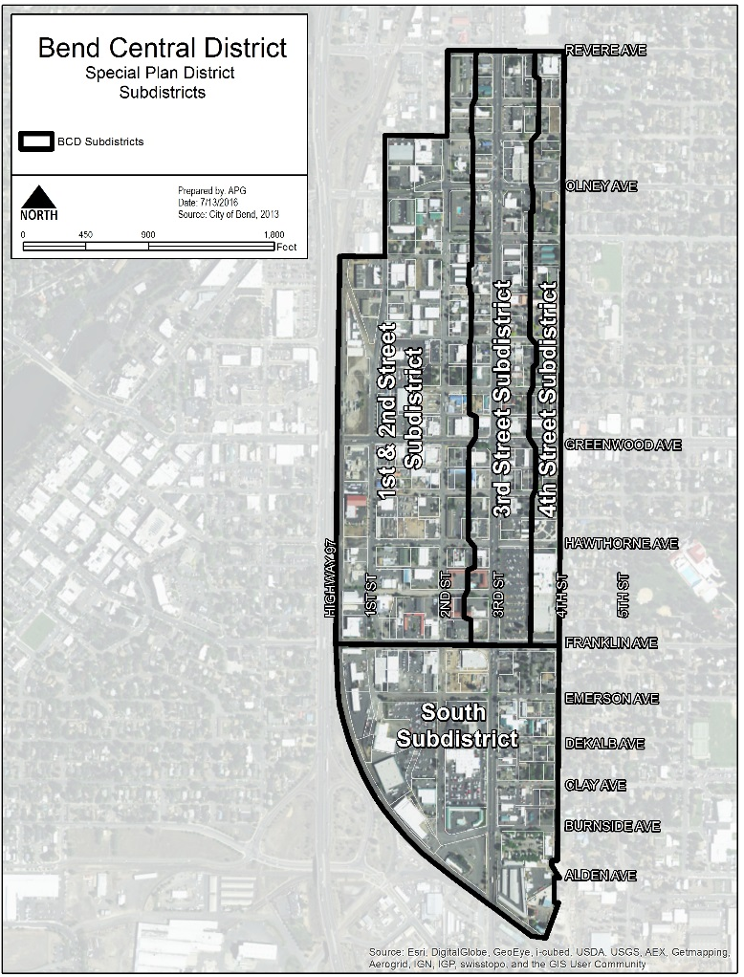
1. 1st/2nd Street Subdistrict. Applies to properties in the vicinity of 1st and 2nd Streets within the BCD and is intended to provide for a mix of office, higher density residential, live/work and small-scale retail uses while also allowing for continuation of existing light industrial/manufacturing uses in the area.
Figure 2.7.3210 Sub-district Map
2. 3rd Street Subdistrict. Applies to properties in the vicinity of 3rd Street between Revere and Franklin Streets and is intended to provide a range of mixed uses including large-scale commercial, retail and limited residential uses.
3. 4th Street Subdistrict. Applies to properties in the vicinity of 4th Street within the BCD and is intended to provide a transition between the more intense central area and existing residential neighborhoods to the east.
4. South Subdistrict. Applies to properties south of Franklin Avenue along and between 2nd and 3rd Streets and is intended to provide a range of mixed uses including high density multifamily and office space above ground floor retail/service uses.

2.7.3210 Applicability.
A. Applicability. In addition to the provisions of the underlying zone, the standards and requirements of this section apply to lands within the BCD boundary as depicted on Figure 2.7.3210. These provisions modify existing standards of the Bend Development Code by applying requirements, limiting allowable uses, or allowing exceptions to general regulations. Where there is a conflict between the provisions of the Bend Central District and those of the underlying zone or other portions of the Development Code, the provisions of this refinement plan shall control.

2.7.3220 Land Uses.
A. Permitted and Conditional Uses. The land uses listed in Table 2.7.3220 are allowed in BCD sub-districts, subject to the provisions of this chapter. Only land uses that are listed in Table 2.7.3220 and land uses that are approved as “similar” to those in Table 2.7.3220 may be permitted or conditionally allowed. The land uses identified with a “C” in Table 2.7.3220 require Conditional Use Permit approval prior to development, in accordance with BDC Chapter 4.4. Land uses identified with an “L” in Table 2.7.3220 are allowed with limitations in accordance with Subsection (D).
B. Existing Uses. Uses and structures that are not in conformance with the provisions in this section but that were lawfully established within the BCD prior to the adoption of this code are considered a permitted use. Expansion or enlargement 25 percent or less of the above referenced uses or structures that are nonresidential will be subject to the provisions of BDC Chapter 4.2, Minimum Development Standards Review, Site Plan Review and Design Review. For expansion or enlargement greater than 25 percent, the conditional use criteria, standards and conditions within BDC Chapter 4.4, Conditional Use Permits, will also apply. Conditions of prior approvals will continue to apply unless modified in conformance with BDC 4.1.1325, Modification of Approval.
C. Determination of Similar Land Use. Similar land use determinations shall be made in conformance with the procedures in BDC 4.1.1400, Declaratory Ruling.
Table 2.7.3220
Permitted Uses in the Bend Central District by Subdistrict
Land Use | 1st/2nd Street | 3rd Street |  |  | 4th Street | South
Residential
Single-Family Detached Dwelling | N | N |  | N |  | N
Attached Single Family Townhomes | N | L (see Subsection D1 below) |  | P |  | P
Multifamily Residential | L (see Subsection D1 below) | L (see Subsection D1 below) |  | P |  | P
Residential as part of mixed use development | P | P |  | P |  | P
Commercial
Retail Sales and Service | L (see Subsection D2 below) | P |  | L (see Subsection D2 below) |  | P
Retail Sales and Service (auto dependent*) | N | N |  | N |  | N
Retail Sales and Service (auto oriented*) | N | C |  | N |  | N
*Medical Marijuana Dispensary and Marijuana Retailer | L (see Subsection D2 below) | P |  | L (see Subsection D2 below) |  | P
*Marijuana Wholesale (more than 75% of sales are wholesale) | P | P |  | C |  | C
*Marijuana Testing, Research and Development Facilities | P | P |  | L (see Subsection D3 below) |  | P
Restaurants/Food Services
– with drive-through* | N | C |  |  | N | N
– without drive-through | P | P |  |  | P | P
Offices and Clinics | P | P |  |  | L (see Subsection D3 below) | P
Conference Centers/Meeting facility associated with a hotel/motel | C | P |  |  | N | C
Lodging (bed and breakfast inns, vacation rentals, boarding houses, timeshare) | P | P |  |  | P | P
Hotel/Motels | P | P |  |  | C | C
Commercial and Public Parking, structure | P | P |  |  | C | P
Commercial and Public Parking, surface lot | P | P |  |  | P | P
Commercial Storage
– enclosed in building and on an upper story | C | C |  |  | P | N
– not enclosed in building | N | N |  |  | N | N
– enclosed in building on ground floor  (i.e., mini-storage) | N | N |  |  | N | N
Entertainment and Recreation
– enclosed in building (e.g., theater) | L/C ( See subsection D6 below) | L/C( See subsection D6 below) |  |  | N | L/C ( See subsection D6 below)
– not enclosed (e.g., amusement) | C | C |  |  | N | C
Wholesale Sales (more than 75% of sales are wholesale) | P | P |  |  | C | C
Hospital | C | C |  |  | C | C
Public and Institutional
Government – point of service intended to serve the entire City (e.g., City Hall, main library, main post office, main Department of Motor Vehicles service center) | P | P |  |  | P | P
Government – branch service intended to serve a portion of the City | P | P |  |  | P | P
Government – limited point of service (e.g., public works yards, vehicle storage, etc.) | N | N |  |  | N | N
Parks and Open Space | P | P |  |  | P | P
Schools | P | P |  |  | P | P
Institutions of Higher Education | P | P |  |  | P | P
Child Care Facility | P | P |  |  | P | P
Clubs and Places of Worship | P | P |  |  | P | P
*Utilities (above ground) | P | P |  |  | P | P
Industrial
Manufacturing and Production | L (see Subsection E3 below) | N |  |  | N | N
Warehouse | L (see Subsection E4 below) | N |  |  | N | N
Transportation, Freight and Distribution | C | N |  |  | N | N
Production businesses (e.g., IT support centers, biotechnology, software/hardware development, broadcast and production studios) | P | P |  |  | P | P
Industrial Service (e.g., cleaning, repair) | L (see Subsection D3 below) | N |  |  | N | N
Marijuana Grow Sites and Marijuana Producing when designated as Mixed-Employment, Industrial General or Industrial Light on the Bend Area General Plan on the Bend Area General Plan | L(see Subsection D4 below) | L (see Subsection D4 below) | N |  |  | L (see Subsection D4 below)
*Marijuana Processing of Cannabinoid Concentrates and Cannabinoid Products when designated as Mixed-Employment, Industrial General or Industrial Light on the Bend Area General Plan on the Bend Area General Plan | L (see Subsection D4 below) | L (see Subsection D4 below) | N |  |  | L (see Subsection D4 below)
*Marijuana Processing of Cannabinoid Extracts when designated as Mixed-Employment, Industrial General or Industrial Light on the Bend Area General Plan on the Bend Area General Plan | L (see Subsection D4 below) | L (see Subsection D4 below) | N |  |  | L (see Subsection D4 below)
Miscellaneous
Small scale alternative energy systems (i.e., rooftop wind turbine or solar panels) | P | P |  |  | P | P
Key to Permitted Uses
P = Permitted
N = Not Permitted
C = Conditional Use
L = Permitted with limitations, subject to Subsection (D) below
D. Limitations. The following limitations apply to those uses identified as “L” in Table 2.7.3220.
1. New residential uses. In order to ensure that the subdistricts retain their established employment focused character, new residential uses in the 1st/2nd St and 3rd St subdistricts are limited as follows:
a. Residential uses that are part of a mixed use development in which non-residential uses occupy at least the floor area equivalent to the entire ground floor area of the development area permitted.
b. Residential uses that are part of a mixed use development in which non-residential uses occupy less than the floor area equivalent to the entire ground floor area of the development area are conditional.
c. Residential uses that are not part of a mixed use development are prohibited.

2. Retail sales and service. Retail sales and service uses must not exceed 30,000 square feet per business. Total area of retail sales and service uses combined must not exceed 50,000 square feet per building.
3. Offices and clinics. Offices and clinics must not exceed 15,000 square feet per business.
4. Manufacturing, production and industrial services. Uses must not exceed 20,000 square feet per business and must minimize potential external effects as follows:
a. All operations must be conducted entirely within an enclosed building.
b. Potential nuisances such as noise, odor, electrical disturbances and other public health nuisances are subject to Chapter 13.45
c. Roof-mounted mechanical equipment, such as ventilators and ducts, must be contained within a completely enclosed structure that may include louvers, latticework, or other similar features. This screening requirement does not apply to roof-mounted solar energy systems or wind energy systems.
5. Warehousing. Warehousing must be accessory/secondary to a primary permitted use (it may not be a single use) and must not exceed 15,000 square feet per building.
6. Entertainment and Recreation. Entertainment and Recreation uses where permitted in subzones of the BCD that are enclosed in a building shall not exceed 50,000 square feet without a conditional use permit.

2.7.3230 Development Standards.
A. The following table provides numerical development standards within the BCD.
Building setback standards apply to any new buildings and any building expansion, including primary structures and accessory structures. Setbacks provide opportunity for pedestrian amenities; building separation for fire protection and building maintenance; sunlight and air circulation; noise buffering; and visual separation. Building setbacks are measured from the building foundation to the respective property line.
Table 2.7.3230
Development Standards in the Bend Central District by Sub-District
Standards | 1st /2nd Street | 3rd Street | 4th Street | South
Minimum Lot area | No minimum | No minimum | No minimum | No minimum
Lot width | 30 feet | 30 feet | 30 feet | 30 feet
Minimum front yard setback | 5 feet1 | 10 feet1 | 5 feet1 | 5 feet1
Maximum front yard setback | 10 feet | 15 feet | 10 feet | 10 feet
Rear and side yard setback | None or 10 feet (see Section C below) | None or 10 feet (see Section C below) | None or 10 feet (see Section C below) | None or 10 feet (see Section C below)
Maximum building height2 | 65 feet or 85 feet (see Sections B and E below) | 65 feet or 85 feet (see Section E below) | 45 feet | 65 feet or 85 feet (see Sections B and E below)
Notes:
1. In all Subdistricts, the first 5 feet of the required front setback will be a dedicated pedestrian easement and will be developed according to the applicable cross section for the fronting street.

2. Equipment used for small scale alternative energy production does not count towards maximum building heights.
B. In the 1st/2nd Street, 3rd Street and South Subdistricts, buildings may be a maximum of 85 feet in height that:
1. Provide at least 10% of any residential units at affordable rates in conformance with BDC 3.6.200(C), or
2..For buildings that do not have a residential component, provide at least 75% percent of required parking within the building footprint of structures. Parking on the ground floor shall have a pedestrian-oriented active façade facing the primary street (see paragraph E.2 below for examples).
C. Rear and side yard setback.
1. There is no rear or side yard setback required, except when abutting a Residential Zone. In such cases, the rear or side yard setback is 10 feet for all portions of the building 35 feet in height or less. Step-backs or other architectural features such as vertical breaks, balconies, bays or stories within gable roofs are required for portions of a building that exceeds 35 feet in height or the height limit of the abutting residentially designated district, whichever is greater.
2. When a public alley abuts a side or rear yard of property, the width of the alley can be included in the additional setback calculation as described in subsections (1) and (2) of this section for the purpose of offsetting the impacts of the building height over 35 feet. The alley does not eliminate the required 10-foot building setback.
D. Multiple Frontage Lots. For buildings on sites with more than one frontage or through lots, the minimum front yard setback standards in Table 2.7.3230 shall be applied as follows.
1. For corner lots with two frontages, the maximum setback standards indicated in Table 2.7.3230 shall be applied to all street frontages.
2. For through lots with two frontages, the maximum setback standards indicated in Table 2.7.3230 shall be applied to only one of the frontages; provided that where the abutting streets are of different street classification, the maximum setback standard shall be applied to the street with the higher classification.
3. For properties with three or more frontages, the maximum setback must be met on two abutting frontages.
E. Buildings exceeding 65 feet in height are allowed subject to the following provisions:

1. Buildings shall be constructed using a combination of architectural features and a variety of building materials. Landscaping should be planted adjacent to the curb line to create a streetscape as illustrated in Figures 2.7.3230 and 2.7.3260. Ground story walls that can be viewed from public streets shall be designed with non-reflective windows totaling a minimum of 25 percent of the wall area and using architectural features (see 2, below). For new buildings, the front building façade must be at the minimum setback for at least 50% of the lot frontage; outdoor public gathering spaces such as plazas are encouraged and count toward the setback requirement; off-street parking is not allowed between the front building façade and the street.
2. Architectural features include, but are not limited to, the following: recesses, projections, wall insets, arcades, window display areas, awnings, balconies, window projections, landscape structures or other features that complement the design intent of the structure and are acceptable to the Review Authority.
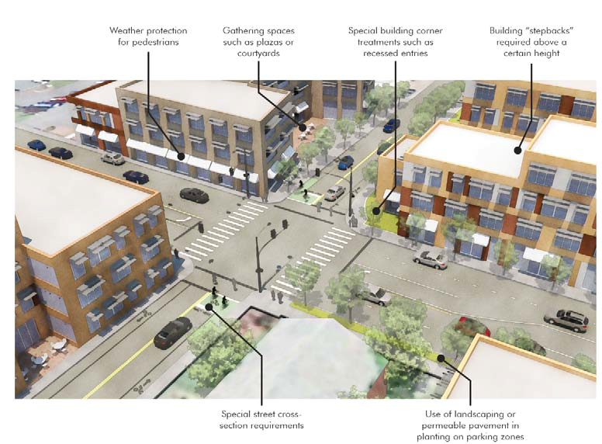
Figure 2.2.3230
Illustration of Use of Architectural Features

F. Buffering. A 10-foot-wide landscape buffer is required along the side and rear property lines between nonresidential uses and any adjacent Residential Zones. The buffer is not in addition to (may overlap with) the side and rear setbacks required in subsection (B) of this section. The buffer shall provide landscaping to screen parking, service and delivery areas and walls without windows or entries. The buffer may contain passive outdoor seating and bicycle parking but must not contain trash receptacles or storage of equipment, materials, vehicles, etc. The landscaping standards in BDC Chapter 3.2, Landscaping, Street Trees, Fences and Walls, provide other buffering requirements where applicable.

2.7.3240 Design Standards
A. All development. Development in the BCD is subject to the design guidelines in BDC Chapter 2.2.800, Subsection (I) except as established below. The standards of this section are in addition to the regulations of BDC Chapter 4.2, Minimum Development Standards Review, Site Plan Review and Design Review Standards. The standards of this section are in lieu of the BDC 2.2.600, Commercial Design Review Standards.
1. Section 2.2.800(I)(3) - Physical, Visual and Experiential Connections. The intent and general approach of this section apply. However, the language referring to traditional business zones and traditional storefront buildings does not apply here.
2. Section 2.2.800(I)(5) - Integrate Building Parapets and Rooftops. The intent and general approach of this section apply. However, the language referring to ornamentation on traditional CB Zone buildings does not apply here. In addition, rooftop solar panels and wind turbines are exempt from the screening requirement.
3. Section 2.2.800(I)(10) - Urban Materials. Does not apply.
B. Single use residential buildings. Single use residential buildings including duplexes, triplexes and multifamily are also subject to the provisions in Sections 2.1.900 and 2.1.1000, with the following exception:
1. The common open space requirement in 2.1.1000(B)(1) does not apply to any property with a residential building located within one-quarter mile of a public park.

2.7.3250 Parking
A. In the BCD, the following parking requirements supersede parking requirements in BDC Table 3.3.300, Required Off-Street Vehicle Parking Spaces. Unless otherwise noted here, other sections of BDC Chapter 3.3, Vehicle Parking, Loading and Bicycle Parking apply.
1. The minimum number of required off-street vehicle parking spaces is established below. Off-street parking spaces may include spaces in garages, carports, parking lots, and/or driveways if vehicles are not parked in a vehicle travel lane (including emergency or fire access lanes).
a. Residential uses: 1 space per unit
b. Commercial uses:
i. Retail or restaurant uses totaling less than 5,000 square feet of floor area: none
ii. Retail or restaurant uses in excess of 5,000 square feet or more of floor area: 1 space per 1,000 square feet of gross floor area in excess of 5,000 square feet.
c. Entertainment uses: Determined by conditional use
d. Hotel/motel: 1 space per room
e. Office uses: 1.5 spaces per 1,000 square feet of floor area
f. Light industrial/manufacturing uses: 0.7 spaces per 1,000 square feet of floor area
g. Public and institutional uses, government uses: 1.5 spaces per 1,000 square feet of floor area

2. Mixed-Use Developments. If more than one type of land use occupies a single structure or parcel of land with no single use occupying more than 80% of the total square feet of the building, the total requirements for off-street automobile parking shall be 75 percent of the sum of the requirements for all uses.
3. The total number of required vehicle parking spaces for an industrial, commercial, or office use may be reduced by up to 10 percent in exchange for providing on-site public open space/green space at the following ratio: one vehicle parking space per 500 square feet of public open space/green space. This reduction is in addition to any reductions taken under Chapter 3.3.300.D.

2.7.3260 Special Street Standards
A. The BCD considered special street standards for streets inside the refinement plan area. The intent of the special street standards is to develop complete streets that enable safe travel for all modes of travel including transit, motorists, pedestrians, cyclists and freight users. On street parking, bicycle lanes and wider sidewalks were identified as elements necessary for safe travel. Below is a typical concept cross section.
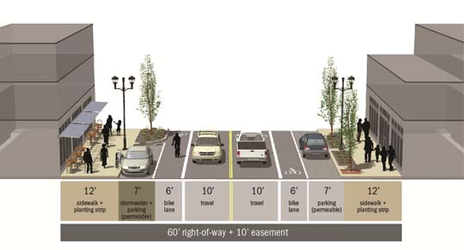
Figure 2.7.3260
Street Design Concept for 2nd/4th Streets

These special street standards will be developed as part of the City’s Transportation System Plan (TSP). Until the special standards are available, the Transportation Improvement Standards of Chapter 3.4 must apply in the BCD.
B. To accomplish new streets, additional street widths and street improvements envisioned for the BCD the following requirements shall apply.
1. The required 5-foot front yard setback along all street frontages must be dedicated as a public easement with site plan approval. This is in addition to any additional right of way that may be required by Chapter 3.4.

2.7.3270 Low Impact Stormwater Management
A. The use of low impact development (LID) techniques to manage stormwater on site is encouraged consistent with the City’s Central Oregon Stormwater Manual. Techniques can include, but are not limited to, the following:
1. Use of on-site pervious paving materials to minimize impervious surfaces allowed within off-street and on-street parking areas and other areas within a development site.
2. Provision of an eco-roof or rooftop garden
3. Use of drought tolerant species in landscaping
4. Provision of parking integrated into building footprint (above or below grade)
5. Provision of rain gardens and bioretention areas on site to filter stormwater runoff
6. Shared stormwater facilities between adjacent properties

2.7.3280 Landscaping
A. The landscaping standards of Chapter 3.2 apply to the BCD except as noted in this section.
B. The minimum required landscaping shall equal 10 percent of the gross lot area for the following uses:
1. Residential – duplex and triplex units and multiple-family developments
2. Commercial and office developments
3. Industrial developments. Seventy-five percent of the required 10 percent site landscaping shall be located within the front yard setbacks and parking areas or other areas visible to the public, unless otherwise required as a condition of approval
4. Mixed-use developments
C. Green roofs and rooftop gardens may be counted toward meeting up to 100 percent of the landscaping requirement.
D. Landscaping in the public right-of-way (for example, street trees and bioswales) may be counted toward meeting the landscaping requirement.

